**Saskatchewan Common Mathematics Assessments Pre Assessment**

**Outcome**: SP3.1 Demonstrate understanding of first-hand data using tally marks, charts, lists, bar graphs, and line plots (abstract pictographs), through:

* collecting, organizing, and representing
* solving situational questions.

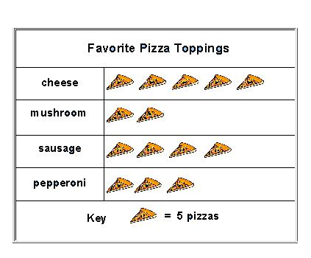

1.

Level

1

1. Which pizza do most people like best? ________________________
2. Which pizza do fewest people like best? ________________________

|  |  |
| --- | --- |
| **Flower Colour** | **Amount** |
| Red | 5 |
| Blue | 3 |
| Yellow | 7 |

2. Kami has three kinds of flowers in her garden.

1. Create a pictograph to show this data.

Title: _____________________________________

|  |  |
| --- | --- |
|  |  |
|  |  |
|  |  |

1. How many more red flowers were there than blue flowers?
2. How many flowers are in Kami’s garden?
3. If Darlana was surveying her entire school to find out what the favourite type of pizza was, how would she best record her data? *(Multiple choice question)*

Level

2

* + 1. Tally chart

______

* + 1. List
    2. Pictograph

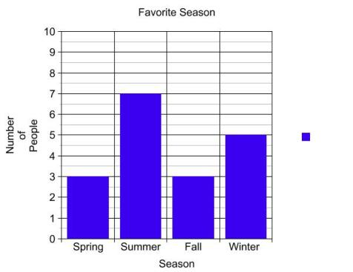

4.

1. How many children like summer best?
2. Create your own question about the bar graph.
3. Answer your question on the line below.
4. Angie made this line plot to show the number of charms on her friends’ bracelets.

Friend’s Bracelet Charms

|  |  |  |  |  |  |  |  |  |  |  |  |
| --- | --- | --- | --- | --- | --- | --- | --- | --- | --- | --- | --- |
|  |  |  |  |  |  |  |  |  |  |  |  |
|  |  |  |  |  |  |  |  |  |  |  |  |
|  |  |  |  |  |  |  |  |  |  |  |  |
|  |  |  |  |  |  |  |  |  |  |  |  |
|  |  |  |  |  |  |  |  |  |  |  |  |
|  |  |  |  |  |  |  |  |  |  |  |  |
|  |  |  |  |  |  |  |  |  |  |  |  |
|  |  |  |  |  |  |  |  |  |  |  |  |
|  |  |  |  |  |  |  |  |  |  |  |  |
|  | *C:\Documents and Settings\scunningham\Local Settings\Temporary Internet Files\Content.IE5\HDI0DAKI\MC900014126[1].wmf* |  |  |  |  |  |  |  |  |  |  |
|  | *C:\Documents and Settings\scunningham\Local Settings\Temporary Internet Files\Content.IE5\HDI0DAKI\MC900014126[1].wmf* |  |  |  |  |  | *C:\Documents and Settings\scunningham\Local Settings\Temporary Internet Files\Content.IE5\HDI0DAKI\MC900014126[1].wmf* |  |  |  |  |
|  | *C:\Documents and Settings\scunningham\Local Settings\Temporary Internet Files\Content.IE5\HDI0DAKI\MC900014126[1].wmf* |  |  |  |  |  | *C:\Documents and Settings\scunningham\Local Settings\Temporary Internet Files\Content.IE5\HDI0DAKI\MC900014126[1].wmf* |  |  | *C:\Documents and Settings\scunningham\Local Settings\Temporary Internet Files\Content.IE5\HDI0DAKI\MC900014126[1].wmf* |  |
|  | *C:\Documents and Settings\scunningham\Local Settings\Temporary Internet Files\Content.IE5\HDI0DAKI\MC900014126[1].wmf* |  |  |  |  |  | *C:\Documents and Settings\scunningham\Local Settings\Temporary Internet Files\Content.IE5\HDI0DAKI\MC900014126[1].wmf* |  |  | *C:\Documents and Settings\scunningham\Local Settings\Temporary Internet Files\Content.IE5\HDI0DAKI\MC900014126[1].wmf* |  |
|  | *C:\Documents and Settings\scunningham\Local Settings\Temporary Internet Files\Content.IE5\HDI0DAKI\MC900014126[1].wmf* |  |  |  |  |  | *C:\Documents and Settings\scunningham\Local Settings\Temporary Internet Files\Content.IE5\HDI0DAKI\MC900014126[1].wmf* |  |  | *C:\Documents and Settings\scunningham\Local Settings\Temporary Internet Files\Content.IE5\HDI0DAKI\MC900014126[1].wmf* |  |
|  | *C:\Documents and Settings\scunningham\Local Settings\Temporary Internet Files\Content.IE5\HDI0DAKI\MC900014126[1].wmf* |  |  |  |  |  | *C:\Documents and Settings\scunningham\Local Settings\Temporary Internet Files\Content.IE5\HDI0DAKI\MC900014126[1].wmf* |  |  | *C:\Documents and Settings\scunningham\Local Settings\Temporary Internet Files\Content.IE5\HDI0DAKI\MC900014126[1].wmf* |  |

Number of Charms

Amy

Kate

Jill

Sarah

1. What is the most number of charms for any friend? _______________
2. Does every friend have a charm on their bracelet? _______________
3. Sheila and Jacquie were at a dugout. They kept track of the creatures they saw. Display this data on a bar graph or a line plot.

Level

3

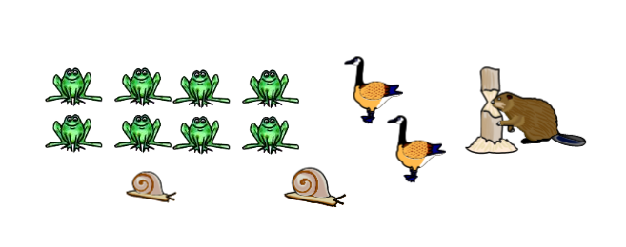

|  |  |  |  |  |  |  |  |  |  |  |  |  |  |  |  |  |  |  |  |
| --- | --- | --- | --- | --- | --- | --- | --- | --- | --- | --- | --- | --- | --- | --- | --- | --- | --- | --- | --- |
|  |  |  |  |  |  |  |  |  |  |  |  |  |  |  |  |  |  |  |  |
|  |  |  |  |  |  |  |  |  |  |  |  |  |  |  |  |  |  |  |  |
|  |  |  |  |  |  |  |  |  |  |  |  |  |  |  |  |  |  |  |  |
|  |  |  |  |  |  |  |  |  |  |  |  |  |  |  |  |  |  |  |  |
|  |  |  |  |  |  |  |  |  |  |  |  |  |  |  |  |  |  |  |  |
|  |  |  |  |  |  |  |  |  |  |  |  |  |  |  |  |  |  |  |  |
|  |  |  |  |  |  |  |  |  |  |  |  |  |  |  |  |  |  |  |  |
|  |  |  |  |  |  |  |  |  |  |  |  |  |  |  |  |  |  |  |  |
|  |  |  |  |  |  |  |  |  |  |  |  |  |  |  |  |  |  |  |  |
|  |  |  |  |  |  |  |  |  |  |  |  |  |  |  |  |  |  |  |  |
|  |  |  |  |  |  |  |  |  |  |  |  |  |  |  |  |  |  |  |  |

1. Write a question you could collect data on. Make up some data you could graph.

Level

4

* 1. What question will you ask?
  2. Organize your pretend data with tally marks, a list or a table.
  3. Draw a bar graph to show your data.

|  |  |  |  |  |  |  |  |  |  |  |  |  |  |  |  |  |  |  |  |
| --- | --- | --- | --- | --- | --- | --- | --- | --- | --- | --- | --- | --- | --- | --- | --- | --- | --- | --- | --- |
|  |  |  |  |  |  |  |  |  |  |  |  |  |  |  |  |  |  |  |  |
|  |  |  |  |  |  |  |  |  |  |  |  |  |  |  |  |  |  |  |  |
|  |  |  |  |  |  |  |  |  |  |  |  |  |  |  |  |  |  |  |  |
|  |  |  |  |  |  |  |  |  |  |  |  |  |  |  |  |  |  |  |  |
|  |  |  |  |  |  |  |  |  |  |  |  |  |  |  |  |  |  |  |  |
|  |  |  |  |  |  |  |  |  |  |  |  |  |  |  |  |  |  |  |  |
|  |  |  |  |  |  |  |  |  |  |  |  |  |  |  |  |  |  |  |  |
|  |  |  |  |  |  |  |  |  |  |  |  |  |  |  |  |  |  |  |  |
|  |  |  |  |  |  |  |  |  |  |  |  |  |  |  |  |  |  |  |  |
|  |  |  |  |  |  |  |  |  |  |  |  |  |  |  |  |  |  |  |  |
|  |  |  |  |  |  |  |  |  |  |  |  |  |  |  |  |  |  |  |  |

* 1. What is your solution for the problem? Tell how your graph helped you to solve the problem.